FINAL EXAMINATION
TIME ALLOWED: 90’
Subject: Linear Algebra.
No books allowed.

- Show that the complex number 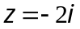 is a root of the equation
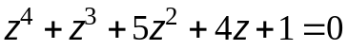 and hence find the other three roots.
- Find 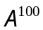, where 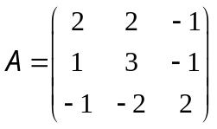 (given 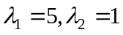 are two eigenvalues of A).

- Let 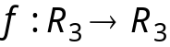 be a linear transformation.
Assume that
  - Find 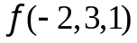.
  - Find the basis and dimension of Kerf.

- Let 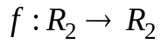 be a linear transformation, whose the matrix with respect to the basis
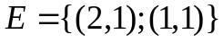 is 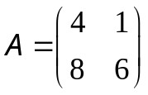
a. Find all eigenvalues and eigenvectors of 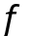.
b. Diagonalize (if possible).
- Determine all value(s) m such that the vector 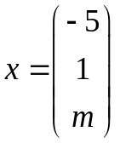 is an eigenvector of the matrix
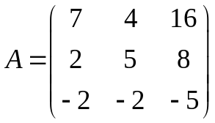.

- Make a change of variables that transforms the quadratic form
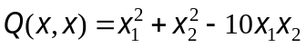 into a canonic form.

-----------------------  -----------------------

